THE WALLSTREETJOURNAL

• ESSAY

• June 7, 2013, 6:30p.m. ET

The Upside of Favoritism

Most bosses like some employees better than others-and that can be good for everyone

By
• PEGGY DREXLER

As the head of the entertainment division of a major public-relations firm in New York, Janelle was in charge of no fewer than 15 junior publicists. She knew that she shouldn't play favorites, but she couldn't help it. Some .employees were just better than others.

But what defined "better"? To Janelle, "better" might mean those employees who delivered exceptional results for clients. More often, though, "better" was entirely subjective and undefined, even to her, as she

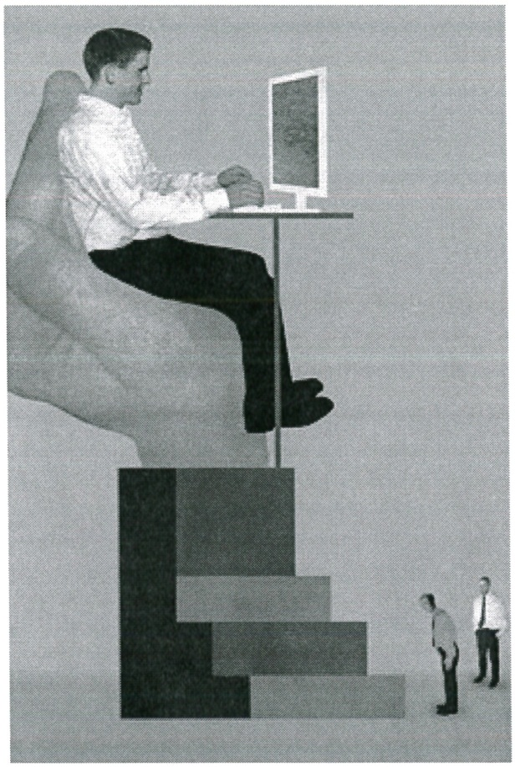
explained to me in the course of my research on women in the workplace. (I have withheld full names to preserve the privacy of my subjects.)

Ellen Weinstein

A 2011 survey conducted found that
92% of senior business executives have seen favoritism at play in employee promotions.

Yet there was a clear advantage to being one of Janelle's favorites. They often got the more interesting accounts. They were also entitled to

http://online.wsj.com/article_email!SB10001424127887324063304578525790605913014-1... 7/5/2013

special perks like free tickets to a client's concert, off
-the-books vacation days, friendlier conversation in the halls and more genuine interest in their personal lives.

The nonfavorites were largely just tolerated. "To put it simply," Janelle told me, "My favorites were my favorites, and I was very nice to them and maybe a little disdainful of the others. I thought the better employees deserved my better treatment, because they'd somehow earned it."

Maybe you've played favorites. Maybe you've been the favorite. Most anyone who's worked in an office or team environment knows that favoritism is a fact of nearly every modern workplace. A 2011 survey conducted by Georgetown University's McDonough School of Business found that 92% of senior business executives have seen favoritism at play in employee promotions, while a quarter of executives admitted to practicing favoritism themselves.

When we talk about favoritism in an office environment, we usually have in mind how preferring some individuals to others can damage the team as a whole, creating rifts and fostering resentment. In order to create a collegial and

productive work atmosphere, we often hear, bosses need to treat everyone the same way.

But this isn't always the case-especially not if done right, and for the right reasons. Recent studies show that playing favorites can actually be a boon, motivating and empowering employees in ways that benefit the entire team.

A 2013 study by the University of British Columbia's Sauder School of Business and published in the Journal of Business Ethics found that there is an advantage to making certain employees feel a little more special than the others. When treated better than others in the group, the study found, employees were more likely to experience heightened self­ esteem, follow workplace norms and perform tasks that benefit the entire group. They were perceived as both more social and more productive.

What's more, the study found, not playing favorites may actually be a disincentive for those employees who, with a little extra attention, might be willing to go above and beyond. These are employees who work hard for outward, explicit approval and who, when unrecognized, may begin to work a little less hard.

As the supervisor of 10 real-estate agents in a large and very competitive New York firm, Jason was constantly trying to reward good work in a way that motivated his employees, without discouraging others. At the same time, he was a firm-and upfront-believer in favoritism. "I was very clear
with the crew," he said. "I said, 'Look, I value results, collaboration, kindness and perseverance. Those of you who display these qualities are most likely to receive preferential treatment from me. Your work life will probably be better." Those on his list of "favorites" changed all the time, and the staff knew that; there were always opportunities to get on the boss's good side.

And when he did single out an employee, he was
•
sure to do it without disparaging the others. "I
rewarded good work on its own, and never in the context of others' performances," he told me. "For instance, I would never tell an underperforming staffer, 'Why can't you be more like so-and-so?' Instead, I'd say, 'Here's where your performance disappointed me, and here's how I'd like to see you make some changes."'

The strategy worked: In his first year, Jason's team outsold all others in the company. For many years

his department continued to have a higher than average rate of retention.

By being careful, selective and clear about his methods, Jason had hit on an important aspect of using favoritism to advantage: transparency. That is, making it obvious to everyone in the office how they can qualify to become a favorite, too. He showed
how favoritism can work when it is done for the right reasons-related exclusively to job performance and at-work behavior.

Janelle, by contrast, thought she was more likely to favor those who worked hardest, but she eventually realized that there were other patterns at play. For instance, she was more likely to favor an employee she had hired herself over one she had inherited. She also had a tendency to like mothers and those who had cats as pets. The message she was sending to her employees wasn't that favoritism was earned, but
that it was bestowed, based not on performance but on Janelle's unstated and arbitrary preferences.

Getting favoritism right is all about how and why you choose to do it. Playing favorites with an employee because the person is a friend outside of work, the best-dressed in the office or simply a cat lover is damaging to morale and to productivity. On

http://online.wsj.com/article_email/SB10001424127887324063304578525790605913014-1... 7/5/2013

the other hand, preferring an employee who works or tries harder, performs better and delivers more consistent results can be a very effective management tool-and it can have beneficial results throughout an organization.

Those who receive preferential treatment from their bosses at one point or another report feeling a greater sense of self-worth in their jobs. They also tend to stick around longer. And eventually, they may become effective leaders themselves.

-Dr. Drexler is an assistant professor of psychology in psychiatry at Weill Cornell Medical College and the author, most recently, of "Our Fathers, Ourselves: Daughters, Fathers and . the Changing American Family. "

A version of this article appeared June 8, 2013, on page C3 in the U.S. edition of The Wall Street Journal, with the headline: The Upside Of Favoritism.

Copyright 2012 Dow Jones & Company, Inc. All Rights Reserved
This copy is for your personal, non-commercial use only. Distribution and use of this material are governed by our Subscriber Agreement and by copyright law. For non-personal use or to order multiple copies, please contact Dow Jones Reprints at 1-800-843-0008 or visit
www.djreprints.com

Email This

http://online.wsj.com/article_email/SB10001424127887324063304578525790605913014-l... 7/5/2013

